|  |  |
| --- | --- |
|  | Please insert formatting marks.  Under File/ Properties, enter the document details. This information will be inserted automatically on the front page and at the bottom of the page.  Formatting should only be done under Format / Styles and Formatting (do not format using the icons on the Formatting toolbar).  Press F11 to skip from one text field to the next. The text fields are deleted automatically once the text has been entered.  Holding Ctrl + A, press F9 to update all fields and directories.  Using the CSD document elements menu, you can add preformatted elements or any accidentally deleted directories, if necessary.  Use the component "image in landscape format" for images without legend. Modify the page format for large-size images with legend to "landscape".  Create table captions for tables which you have taken from other documents by inserting a table component and copying the caption. |
|  | Dldp/HSI  Support on Waste Sector in Albania  *Report on 2013 evidencies* |

Tirana, February 2014

Authors:

Emile Gex (*Environmental Engineer, CSD Engineering, Lausanne*)

Arben Kopliku *(Waste Expert at dldp)*

*Quality assured by Dr. Valbona Karakaçi (dldp) and Félix Schmidt (CSD)*

Table of Contents

1. Introduction 7

2. Cost and tariff methodologies 8

2.1 Methodology on cost calculation 8

2.1.1 Situation on cost calculation 8

2.1.2 Support provided by dldp in 2013 8

2.1.3 Presentation of the methodology 8

2.1.4 Learnings in 2013 9

2.2 Methodology on tariffs 10

2.2.1 Situation on tariffs 10

2.2.2 Support provided by dldp in 2013 10

2.2.3 Presentation of the progressive model 11

2.2.4 Learnings in 2013 11

2.3 Recommendations on cost and tariff 12

2.4 Considerations regarding planning and cost calculation 13

3. Recycling implementation 14

3.1 Situation on recycling and dldp support in 2013 15

3.1.1 Situation on recycling 15

3.1.2 Support provided by dldp in 2013 15

3.2 Lezha situation 15

3.2.1 Presentation of the situation 15

3.2.2 Learnings in 2013 17

3.3 Shkodra situation 18

3.3.1 Presentation of the situation 18

3.4 General recommendations on recycling 21

4. Options for optimization and cost reduction 22

4.1 Situation on optimization / cost reduction and dldp support in 2013 22

4.1.1 Situation on optimization and cost reduction 22

4.1.2 Support provided by dldp in 2013 22

4.2 Optimization of waste collection and transport through interLGU schemes 22

4.2.1 Presentation of the proposed schemes 22

4.2.2 Learnings in 2013 23

4.2.3 General recommendation on interLGU collaboration 24

4.3 Optimization of waste transport through transfer stations 25

4.3.1 Presentation of the situation 25

4.3.2 Support provided by dldp in 2013 25

4.3.3 Learnings in 2013 25

4.3.4 General recommendation on transfer stations 26

5. Measurement campaigns 27

5.1 Situation in LGUs 27

5.2 Support provided by dldp in 2013 27

5.3 General recommendations on measurements 29

6. Tariff recovery and awareness campaigns 29

6.1 Situation in LGUs 29

6.2 Learnings in 2013 29

6.3 General recommendation on tariff recovery and awareness campaigns 30

7. Planning 31

8. Conclusion - overview of the recommendations 32

**TABLE OF ILLUSTRATIONS**

Figure 1: Differences between the estimated and measured waste production 10

Figure 2 : Population data - Differences between the Census and Civil Register 11

Figure 3 : Comparison of the current and proposed tariffs (based on the progressive model) for the regions of Shkodra and Dajç 13

Figure 4 : General scheme on cost / tariff calculation, optimization and monitoring 14

Figure 5: comparison of cost calculated according to different sources 15

Figure 6 : waste recovery in Lezha 16

Figure 7 : Financial statement of the waste management system in Lezha (2012/2013) 18

Figure 8: Scenario 1 representation 19

Figure 9 : Scenario 1 - Mechanical sorting of the waste (Herceg Novi - Montenegro) 19

Figure 10 : Scenario 2 - 3 collection ways for plastic and paper waste 21

Figure 11 : Financial statement for the second scenario - 3 collection ways for plastic / paper waste 21

Figure 12 : localisation of the regions and LGUs (source: googlemap) 24

Figure 13 : Theoretical reduction of the waste management cost with an interLGUs scheme for selected LGUs 25

Figure 14 : Average regional coverage of the waste management system 25

Figure 15 : InterLGU groups and transfer stations as a mean to reduce the costs of the waste management system 26

Figure 16 : Financial results of Shkodra's transfer station feasibility study 27

Figure 17 : Threshold between transfer stations inducing additional cost or reducing the cost of the system – Study conducted by ADEME (Agency of Environment and Energy Monitoring, France) 28

Figure 18 : Estimated and measured waste production in Shkodra, Lezha and Shengjin 29

|  |
| --- |
| Disclaimer  Dldp and its collaborator CSD Engineers confirms having executed and performed the mandate with the requested diligence, that the results and conclusions are founded on the current status of knowledge as described in the report and that these have been developed in accordance with the generally accepted principles of the relevant field and to the best of one’s knowledge.  The authors assume that:   * all information and documentation presented to it by the principal and third parties are genuine, complete and true; * the results of the present report will not be used in part; * the results of the present report will not be used for a purpose other than agreed upon and may not be applied to another object or to changed circumstances.   Otherwise, programme disclaims any liability for damages of any kind.  If a third party uses the results of the present report in order to take decisions, dldp disclaims any liability for any kind of direct or indirect (consequential) damages. |

ACKNOWLEDGE:

Dldp acknowledges the support of a number of experts and LGU-s, who contributed with their recommendations and know-how Auréline Grange (CSD), Eduard Cani (REC), Konalsi Gjoka (independent expert), Redion Biba (COPLAN), Edlir Vokopola (URI), Ermelinda Mahmutaj (EDEN), Erion Berisha (AGC), Arben Gjuraj (Commune of Dajç), Beqir Arifaj (Municipality of Puka), Nikolin Prendi (Municipality of Lezha), Ahmet Omi (Municipality of Shkodra), Agustin Gjini (Commune of Shengjin) and inter LGU group of local experts operating in the frame of dldp etc.

# Introduction

Dldp has been recognized as an important partner in the waste sector in Albania, for its actions conducted for more than seven years, mainly in the north of the country. In the previous years, dldp has been supporting the local governments in the planning and implementation of the Waste Management Plans, with the aim to achieve the national objectives. Although involved at the local scale, dldp has always been closely working with the national entities, sharing learnings and experiences coming out from the field, through national conferences and close collaboration with the involved ministries and national institutions (Ministry of Environment, Ministry of Transport, Ministry of Tourism, Water Regulatory Entity, for instance).

In 2013, dldp and partners working in the waste sector have been involved in different projects and studies, among which:

* A manual on **cost and tariff** methodology has been edited, proposed and tested in different LGUs,
* Support has been provided to Shkodra for assessing and choosing a sustainable scenario for **recycling** and including recycling activities in the new tender for the service provider,
* Support has been provided in Lezha to monitor recycling activities and to assess the feasibility of extending this service to the whole territory and to Shengjin, under an interLGU cooperation,
* Support has been provided in Puka and Malesia e Madhe regions, to set **interLGU cooperation** on waste,
* The feasibility of a **transfer station** for Shkodra has been assessed,
* Surveys on **waste production and composition** have been conducted in Shkodra and Lezha,
* **Awareness campaigns** on tariff recovery have been conducted in Velipoja, Ana e Malit and Lezha.

All these themes are of national concern.

The objectives of this report are to inform on challenges that local governments are facing in the application of the national plan and to share observations, findings and results that came out of the actions led in 2013. Some of these elements may draw policy makers’ attention and complete their vision of the Albanian waste sector’s situation, when adapting legal and institutional frameworks.

The last section of the report summarizes the recommendations issued from dldp analysis in 2013, for each sector.

# Cost and tariff methodologies

## Methodology on cost calculation

|  |
| --- |
| ***Objective: the budget of the waste management service must be based on a cost analysis*** |

### Situation on cost calculation

Most of the LGUs of the country, especially in rural areas, do not have the capacity, nor a tool enabling them to properly calculate the cost of the waste management service. As a consequence, in these LGUs, neither the budget of the service, nor the tariff setting are based on any cost calculation and cannot be justified toward the population. This situation leads to significant differences between the waste management budgets of the different LGUs, that do not reflect differences in the quality of the service provided (from 150 LEK/inh/y to 690 LEK/inh/y depending on the LGU - survey realized in the region of Lezha).

There is a need for a tool supporting the LGUs staff to calculate the real cost of the service, in order to adjust the budget, the contracts of the service provider when the service is outsourced, and finally, the tariffs.

### Support provided by dldp in 2013

Historically, dldp started supporting the LGUs for the cost calculation in parallel with the support on waste management plan implementation. At that time, it appeared necessary to calculate the cost of this new service in the municipalities where it was about to be implemented, in order to assess different operational scenarios, orientate the best choice and calculate the impacts on the local budget. This support was successful, highly appreciated from the beneficiaries and there was a demand for replication.

In order to disseminate the learnings of this experience, dldp developed a methodology on cost calculation, and edited in 2013 a manual (in English and Albanian) that has been presented at the national conference in July. This manual can be used by any interested LGU, and could serve as a bases for a national standard on cost calculation.

The objectives of the use and dissemination of this methodology is to enable the LGUs:

* To assess the cost of implementing the waste management plan and chose the best scenario
* To calculate the cost of the service and use it as a base for budget setting, contracting and tariff setting

### Presentation of the methodology

The full methodology is presented in the guideline “Calculating the cost for solid waste management at local government unit level in Albania, dldp, April 2013” and will not be detailed here.

The aim of the methodology is to structure the cost in 3 major cost categories :

1. **Operation** costs of the service, which includes collection, transport, maintenance and personnel costs
2. **Amortization** costs, based on the required basic investments (bins, trucks, facilities)
3. **Landfilling** costs, based on the gate fees

Several basic parameters influence the cost of the waste management plan and are required to properly estimate the cost of the system. These basic data are :

* Waste production (volume or weight)
* LGU population
* Typology of the LGU (urban, rural, mixed)
* Distance traveled by the trucks (1. To collect the waste, 2. To go to the landfill)
* Collection frequency

Based on this basic data, the methodology allows to calculate the costs for the primary investment (bins and trucks), the collection and transport, the trucks’ maintenance, the landfilling and for the amortization. Finally, the model was designed to provide the following outputs, which allow a comparison of the costs of the different waste management systems tested or implemented in the LGUs :

* Primary investment (bins and trucks) [€,lek]
* Annual cost (= the budget for the service) [€,lek]
* Annual cost per ton [€,lek/t/y]
* Annual cost per inhabitant [€,lek/inh/y]

**Limitations of the model**

The model developed is a tool mainly directed towards LGUs providing a basic service and with no prior knowledge on how to calculate the cost of their waste management plan. It is not convenient for a fine and detailed analysis of the costs of more advanced LGUs, providing additional services, such as recycling.

### Learnings in 2013

The methodology developed provides a standard for costs calculation and was greatly appreciated by the LGUs who applied it. The model was mostly convenient for LGUs providing a basic service. For more advanced LGUs, an upgraded model taking into account recycling and allowing more flexibility in the operational choices (several trucks sizes, various collection frequency) is required.

Another limitation of the model is the lack of accurate figures for the two most important parameters of the cost model : the waste production and the population living in the LGUs. The national plan provides reference figures for waste production (1 kg/inh/d in urban areas and 0.6 kg/inh/d in rural areas). However, both population and waste production figures are often uncertain or unknown.

In 2013, dldp led measurement campaigns in Shkodra, Lezha and Shengjin to obtain accurate figures of the waste production. The Figure 1 compares the figures used by the LGUs as a contractual base with the service provider, with the real figures obtained from the truck weighing campaign and the recommendation of the national plan.

|  |  |  |  |
| --- | --- | --- | --- |
|  | **Waste production [kg/inh/d] per capita** | | |
|  | **Base for contract** | **Measurements** | **National plan** |
| **Shkodra** | 1 | 0.7 | 1 |
| **Lezha** | 0.5 | 0.47 (weighted average)  0.72 (high season)  0.43 (low season) | 0.7 |
| **Shengjin** | 1.6 | 0.44 (weighted average)  0.58 (high season)  0.41 (low season) | 0.4 – 0.7 |

Figure 1: Differences between the estimated and measured waste production

The results obtained show a significant discrepancy between the estimated and measured waste production, which highly influence the cost calculation. The culture of working with real figures must be introduced in the country, as it is one of the necessary prerequisite to show good governance principles application and to enable an efficiently calculation of the costs and the establishment of a real budget.

Regarding the population data, the differences between the Census and Civil Register are striking for some of the municipalities. In the worst case, the difference reaches 50%, as shown in Figure 2.

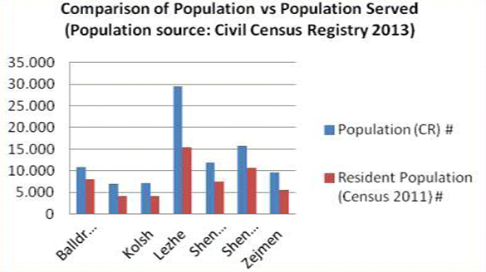

Figure 2 : Population data - Differences between the Census and Civil Register

The assessment of the cost of the service shows important differences, depending on the population database chosen for the cost calculation.

## Methodology on tariffs

|  |
| --- |
| ***Objective: the cost of the service must be financed by the collection of the fees (tariff)*** |

### Situation on tariffs

In most LGUs, the tariff does not reflect the cost of the service and lacks transparency, as it is not based on a cost analysis. The latest issue implies that the Head of Service cannot explain to citizens how the tariff is set and for which services the citizens pay. Moreover, the tariffs often do not cover the cost of the system.

### Support provided by dldp in 2013

In 2013, dldp proposed a methodology tool for tariffs and 3 tariff models based on cost calculation have been developed and tested in LGUs, but not implemented, yet.

The 3 models propose to calculate the tariff, based on different parameters:

* Model 1 is based on “**people**” : the tariff is calculated according to the number of people in a family and the number of employees working in a business or institution.
* Model 2 is based on “**surfaces**” : the tariff is calculated according to the surface of the building occupied by the family, the business or the institution.
* Model 3 or also called “**progressive model**” : the tariff is calculated according to a mix of different factors known to influence the waste production (mainly based on the water tariff model).

The 3 models have been presented at the National Conference and the “progressive model”, based on the concept of the water tax model was selected for further development.

### Presentation of the progressive model

The concept of the progressive model is based on the fact that the tariff should be specific to each user and based on parameters recognized to influence the production of waste (polluter-pays principle) or the cost of the service (equivalency principle). The methodology is fully presented in the “Manual for tariff setting” and in the merged version “Cost and Tariff Manual” will not be detailed here.

The tariff calculation of the progressive model relies on the following parameters :

1. **Size factor** : the tariff increases with the number of persons per household, the number of employees per institution and the surface occupied per business or industry.
2. **Garden factor** : the tariff increases if the user (household, business / industry or institution) has a garden (important production of bio waste).
3. **Distance factor** : the tariff increases if the user is located far from the city / village center (the distance increases the collection cost).
4. **“Big / special” producer factor** : the tariff is increased for important waste producers that are not impacted by the other factors (i.e. a business occupying a reduced surface but producing a large amount of waste per day).
5. **Incentive factor** : the tariff is reduced for users applying legal and approved measures of waste reduction (e.g. individual waste composting).

Based on these parameters and their per user value, adjusting factors are applied to compute the tariff per household, business, industry or institution.

### Learnings in 2013

The progressive model has been fully developed in the municipalities of Dajc and Shkodra.

**Difficulties and limitations**

One of the main difficulties that arose from the application of the progressive model is the limited availability and accuracy of the population and buildings’ surface data. The uncertainty on population data appears once again as a problematic situation, as well as the limited access of LGU to the family register[1].

A major limitation to the use of the model is the law on small businesses establishing that “the tariff for small businesses may not exceed 10% of the tax level shown in the relevant Small Business Tax Table”[2], which implies that in some cases, the tariff calculated with the progressive model might not be legal for businesses.

**Feedbacks**

Despite of the difficulties on data collection, the commune of Dajç showed a strong interest for the progressive model. The main advantages pointed out were the fairness and the transparency of the model, which enabled a simplified communication and justification of the tariff towards the population. It was also mentioned that the use of a “unified methodology is a first step for an interLGU collaboration”, emphasizing the need for a standard tarification methodology.

**Comparison between current tariffs and tariffs based on the progressive model**

The following table (Figure 3) presents the discrepancies between the current tariffs and the tariffs based on the progressive model for two test communes, Shkodra and Dajç.

|  |  |  |  |
| --- | --- | --- | --- |
|  |  | **Current tariffs [LEK/y]** | **Progressive model tariffs [LEK/y]** |
| **Shkodra** | Household | 4800 lek/family/year | Average : 3’971 |
| Business | Big businesses  Min – max : 25’000 – 70’000  Small businesses  Min – max : 5’000 – 20’000 | Average : 5’907  Min – max : 5’106 – 30’069 |
| Institution | 33 lek/m2 and NGOs 3000 lek/year  Average : 10 000 lek/year | Average : 14’862  Min – max : 5’106 – 30’069 |
| **Dajç** | Household | 500 – 1’600 | Average : 2’622  Min – max : 1’935 – 3’871 |
| Business | 1’000 – 25’000 | Average : 4’536  Min – max : 3’484 – 8’516 |
| Institution | 5’000 | Average : 6’348  Min – max : 3’484 – 14’322 |

Figure 3 : Comparison of the current and proposed tariffs (based on the progressive model) for the regions of Shkodra and Dajç

## Recommendations on cost and tariff

The recommendations formulated to policy makers on cost and tariff are the following ones:

1. There is a need for a **national standard on cost and tariff calculation**. Methodologies proposed by dldp can serve as a basis to establish it. As a recommendation, a regulatory entity should be named as a leader, to revise and modify the proposed methodologies, and to adapt the legal framework, in order to enable their implementation, as a national standard. Policies will be needed to make the local governments set their budgets and tariffs based on a proper cost calculation, following the methodologies. Dldp could support by following up the process and supporting the setting of the methodology.
2. The cost and tariff methodology will allow for some comparisons between the different systems implemented in the LGUs and will enable a monitoring at a national level, which can help to prevent the risks of corruption in this sector. To correctly use this methodology, a broad **training** of the municipalities’ staff should be undertaken. Dldp could provide a support and train a governmental unit which would then be in charge of training the staffs at the LGU level.
3. Planning and implementing a waste management plan is the first step to manage the cleaning service. The second step is the **monitoring** of the system, which is still very weak. Locally, monitoring is essential to pilot the service and to reflect the improvements in the cost analysis and in the tariffs. **Monitoring and reporting at national level** is required for planning purposes (evaluation of the needs and location of infrastructures, for example). The national government should also implement mechanisms to force LGUs to monitor their waste production (e.g. by weighting the trucks at the entrance of the landfill) and costs and to relay this essential information to the regional/national government. Policies should be introduced to oblige a follow up from the LGU, to measure, to register and to report, at least the quantities of waste collected and disposed. An important and necessary effort should be made to implement a working culture based on the use of real data.
4. **Population** is a basic and essential data for any planning, budgeting and fiscal purposes. Local and national governments need accurate data on population. Efforts must be realized in collaboration with the register offices to set accurate data on population. National government should issue instructions about handling the differences between CENSUS and data’s reported from LGU_s. People should pay, where they are registered. The access of LGU-s in the data’s of civil register (nr of persons/family) must be assured.
5. The changed **law on small business**, which limited in the past the amount of fee paid by the small businesses, is a good step ahead toward the implementation of the principal “polluters pays”. Even the existing structures like Prefecture and State Controlling could better paly they role in monitoring the calculation of cost service through budgeting proceeses where they have a “say”.
6. Efforts must be focused on **increasing the recovery rate** of tariffs (proactive collection of fees, sanctions, incentives, awareness campaigns,…).

Finally, the objective on cost and tariff can be summed up in the following illustration:

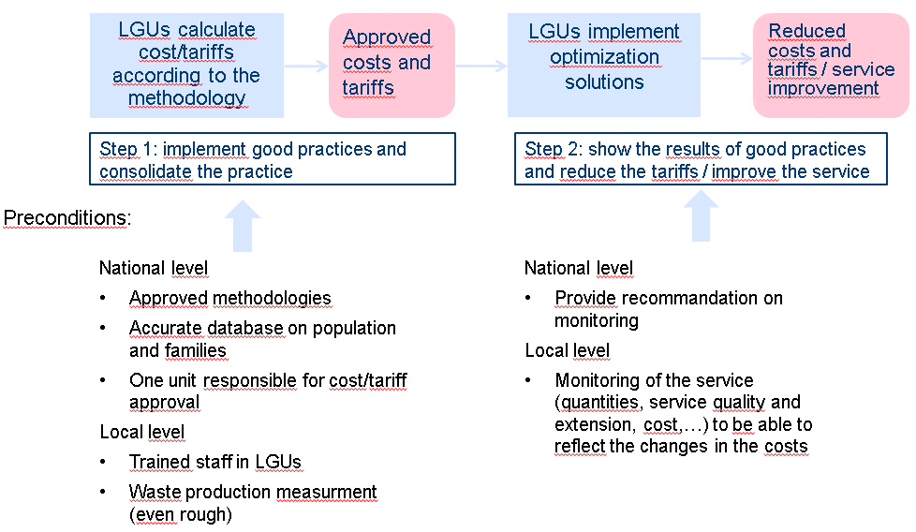

Figure 4 : General scheme on cost / tariff calculation, optimization and monitoring

## Considerations regarding planning and cost calculation

As mentioned before, dldp support on waste started with the elaboration of local waste management plans. At the time of implementing these plans, it appeared necessary to calculate the cost of this new service, in order to assess different operational scenarios, orientate the best choice and calculate the impact on the local budget.

**The cost model was used as a planning tool at local scale.**

Based on this, the model on cost calculation has been elaborated and used to calculate the cost of waste management at the municipal level. It was as well used for regional consideration on waste optimization, such as evaluating the cost in different interLGU schemes or evaluating the impact of a transfer station on transport costs.

This experience capitalized at the local scale contributed to feed the regional waste management plan for Shkodra and Lezha region, developed by Selea.

Today, one limitation to calculate a regional cost, and moreover a national cost, is the coexistence of different basis for the calculation. The following graph compares the cost of the waste management at municipal scale, according to three different sources: the local plans, the calculation of the cost model elaborated by dldp and the average national cost that comes out from the national plan. It shows big discrepancies.

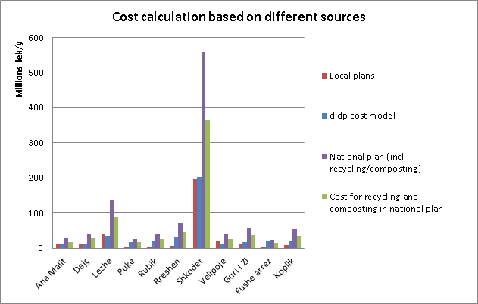

Figure 5: comparison of cost calculated according to different sources

The cost model generally shows higher figures than the local plans. Indeed, these latters consider dumping the waste, when the cost model considers a legal disposal at Bushat landfill, which generates higher transport costs, especially for LGUs located far from the landfill (Puka: 65 km, Fushe Arrez: 90 km). In the case of Velipoje, the local plan considers a higher production of waste in the summer season, when the cost model doesn’t consider this parameter.

The cost calculated based on the national plan is from two until eight times higher than the local plans. Two main reasons explain this difference. The national plan considers recycling and composting, which count for 65% of the cost and are not considered in the local plan, nor in the dldp cost model. Moreover, the waste production considered in the national plan is generally higher than the reality (see chap. 5.2 p.27).

These large differences show the need for a monitoring on waste production and a common basis on cost calculation, set as a standard, flexible enough to allow the consideration of local conditions (technical, economical, topology, etc.). Once this standard established, planning projects at regional scale could be compared and evaluated from the economical point of view. Such a tool could help assessing territorial options such as the best position to implement regional facilities (landfills and transfer stations, for example).

**An upgraded version of the dldp cost model could be used as a planning tool at regional and even national scale.**

# Recycling implementation

|  |
| --- |
| ***Objective: evaluate the national objective toward the local situations on recycling*** |

## Situation on recycling and dldp support in 2013

### Situation on recycling

The National Strategy on waste fixes ambitious objectives regarding recycling : by 2015 a 3 streams waste collection should be implemented nationwide and a sorting rate of 25% should be reached.

The current situation in the LGUs is far from this objective. Indeed, nearly all LGUs do not have any sorting facility, neither a budget to implement and operate sorting facilities. The sorting activities are presently conducted under difficult working conditions by the informal sector, outside of any institutional or legal framework.

### Support provided by dldp in 2013

In Lezha, a two streams collection system and a sorting center have been implemented in the city center in 2012, thanks to different donors and support, including dldp. A survey on waste production and composition has been conducted in 2013. A new tender document is elaborated to expand differentiated collection through combining door to door with curbside collection, therefore increase rate of recyclables recovery. Dldp is studying the extension of the recycling service to the whole territory of Lezha and to its neighbor Shengjin.

In Shkodra, dldp supported the integration of recycling activities in the contract of the service provider, and elaborated new tenders including this new task. Several recycling scenarios were examined in details and compared. Dldp also provided support for the implementation of the recycling activity (infrastructures, institutional and contractual framework, awareness campaign).

## Lezha situation

### Presentation of the situation

The annual weighted average of waste production in Lezha reaches 14[3] t/d which is equivalent to 5'120 t/y. A 2 streams collection with specific bins is already implemented and serving 90% of the city center (Zone A), therefore covering almost 40 % of the registered population in Lezha. Paper, plastics and metals are collected separately and transported to a sorting center, where they are manually sorted, pressed and packaged to be sold, as shown in the illustration below.

Figure 6 : waste recovery in Lezha

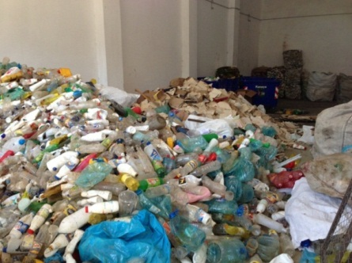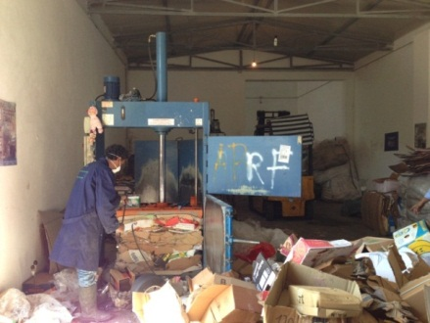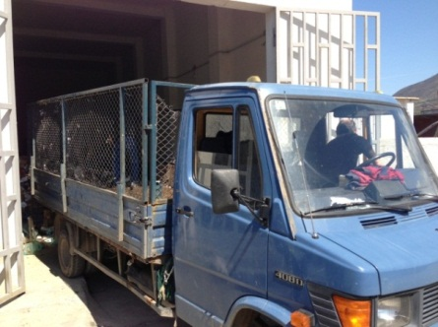

Data reported indicate that at present (2013), the Sorting Center processes around 20 ton/month, at a daily average of about 674 kg/day. This represents 26 % of the total recyclable waste of 2’600 kg/day generated in the Zone A[4], or about 5% of the total of waste amount of about 14 t/day generated in the city of Lezha, when in 2012, 123 kg/d have been sorted in average. Collaboration with big producers, such as businesses, contributed increasing this amount.

The next table shows the cost and revenue of recycling in Lezha, in todays situation:

|  |  |  |
| --- | --- | --- |
| Operation and maintenance of sorting facility | 12’958 €/y | **Cost : 3’534 €/y** |
| Amortization (15 years, no interest considered)  *Investment (bins + sorting facility) : 99’910 €* | 6’660 €/y |
| Revenue (sale of sorted material) | 11’174 €/y |
| Savings (reduction of the quantity of waste to be transported and disposed in landfill) | 4’910 €/y |

Figure 7 : Financial statement of the waste management system in Lezha (2012/2013)

These figures show that, in the current situation, the costs of the system are not covered by the savings and the revenue. The project of this sorting center has been implemented assuming the hypothesis of processing 4’200 kg/d of sorted and recyclable waste in average. The experience showed that the population was not informed and educated enough to the topic to efficiently use the two bins collection system, which dramatically reduced the amount of material to process. In the current situation, recycling the waste is more expensive than collecting and disposing them at the landfill. The recycling activity could get to an economic balance by increasing the amount of waste processes, without increasing the operation costs of the sorting center, nor of the collection.

It comes out from the table that the amortization of the infrastructure represents an important proportion of the cost. Thus, the LGU can more easily benefit from recycling if the costs related to the infrastructure are supported by an external financing.

### Learnings in 2013

Several important learnings have emanated from the actions and analyses realized in Lezha during 2013.

Firstly, it has been observed that in general the population do not use the bins properly. Indeed, mixed waste was found in Lezha’s two types of bins. This emphasizes the fact that it is too early to implement a 3 streams collection system as promoted by the national strategy.

The second learning concerns the 5% waste recovery rate obtained in Lezha, a commune benefiting from the support of the Mayor and of several donors. Even with a strong support, the recovery rate is relatively low and far from the government’s objectives for 2015.

The situation of Lezha shows that plans and business plans should consider very careful the quantities of recyclable waste that can be taken out from the bins and processed. It is firstly important to quantify the volume of recyclable material and then, to estimate which part of it can realistically be taken out and recycled. It takes many years to build a system where 90% of paper, plastic and glass are recycled. Education and incentives are necessary.

Finally, important investments are necessary to implement such a waste management system. The amortization of the installations must be taken into account in the cost of the recycling activities. Moreover, revenues and savings should cover the cost of the system. If not, an external support is necessary, but the system will remain not economically sustainable.

The major learning of 2013 stresses out the fact that the national objective appears as very ambitious and hardly achievable in the time granted, especially for communes with less or no support to implement the required infrastructures.

## Shkodra situation

### Presentation of the situation

The municipality of Shkodra produces about 77 tons of waste per day (20’100 t/y). The Mayor showed a strong interest in implementing and formalizing recycling activities in the city. Two scenarios were therefore analyzed during 2013 in order to choose the most efficient one, from the operational and financial points of view. As the result of these assessments could be useful for other LGUs, they are presented below.

#### First scenario – sorting plant without at source sorting

The first scenario is based on the model implemented in Montenegro (Herceg Novi) and consists in constructing a sorting plant where the mixed waste is mechanically and manually sorted in order to extract valuable materials, without any at source presorting:

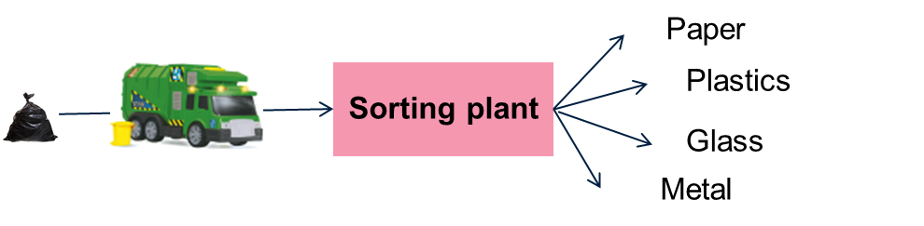

Figure 8: Scenario 1 representation

The feasibility of this scenario for Shkodra has been assessed by calculating the operation costs based on the Montenegrin experience, translated into Shkodra situation and Albanian costs. The income based on the sale of sorted materials has been estimated based on the market price and savings related to the reduction of the amount of waste to transport and dispose of in a landfill and have been calculated based on the cost model. Finally, the construction cost of the mechanical part has been set through a call for tenders, gathering three offers from different providers. The option of constructing such a facility with local resources and “second hand” material, as it is the case in other municipalities in the country, has not been considered for safety and operational reasons. These facilities are industrial units, that need to be precisely designed and constructed to be fully operational. By constructing these using second hand material and non-experienced designers and constructors, the risk that the line would never work properly, getting obstructed and blocked with waste, leading to frequent stops, is high. Moreover, the facility would hardly be compliant to workers safety rules, industrial danger such as fire and hygienic conditions.

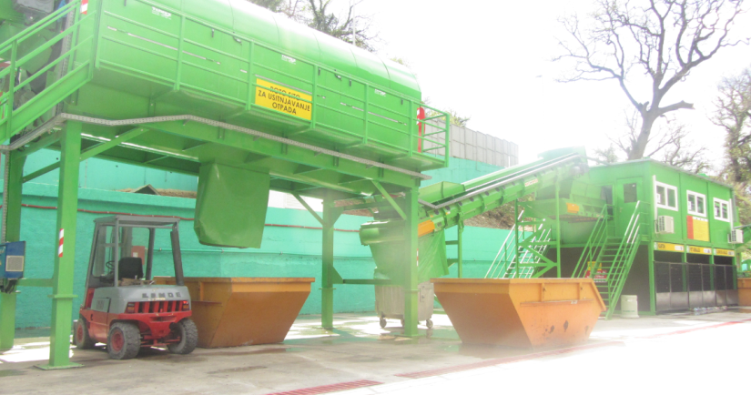

Figure 9 : Scenario 1 - Mechanical sorting of the waste (Herceg Novi - Montenegro)

***Findings***

1. Sorting rate:

According to results reported in Montenegro and to information given by the providers of these infrastructures, this kind of installation cannot provide a sorting rate greater than **10 - 12%** of the waste production. This rate is a technical limit that remains below the national objective.

1. Economical sustainability:

The calculation showed that the scenario could not be economically sustainable if the primary investment exceeded 270’000 €. But, based on the data gathered through 3 suppliers and based on the data available in Montenegro, **the minimum investment for this kind of installation is of about 1’100’000 to 1’300’000 €.** The investment required being 4 to 5 times higher than the affordable maximum investment, therefore this scheme is not economically sustainable.

1. Risk consideration:

The majors risks are not only financial but also technical (**high risk of fire**) or linked to **sanitary conditions**. Indeed, health and hygienic risks arise from the manual sorting of the mixed waste containing, inter alia, hospital and hazardous waste.

For all these above-mentioned reasons, this scenario has been rejected.

#### Second scenario – collection points, at source sorting

The second scenario proposed is based on 3 collection means (Figure 10) :

1. Collection points : 2 collection points are implemented in the city, where the sorted waste is bought to the population. Waste producers are asked to bring their plastic and paper waste to one of these collection points.
2. Informal sector : sorted material is bought to representative of the informal sector, which collect it in specific areas, such as restaurants. An agreement would be signed between the informal sector, the municipality and the waste producers to facilitate the collection and improve the working conditions.
3. Specific truck collection : for institutions, businesses and industries producing an important amount of plastic and paper waste, a specific collection and transport is foreseen.

The waste gathered by these three sources is transported to a plant, where it is separately stored, pressed and stored in “balls” until getting a sufficient amount to be sold and transported by truck.

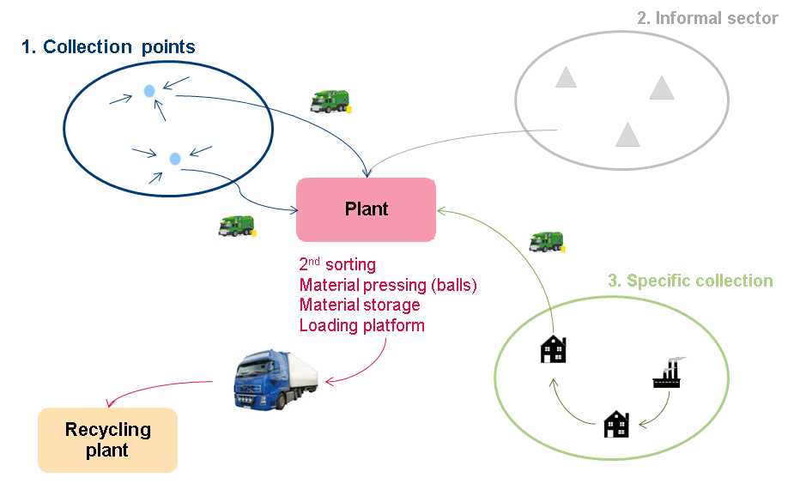

Figure 10 : Scenario 2 - 3 collection ways for plastic and paper waste

In this scenario, the waste collection, transport and treatment is outsourced to the company through a Public Private Partnership (PPP), which means that :

* The investment and operation costs of the collection points and plant are under the responsibility of the company, as part of the contract.
* The company can sell the material (generates revenues).
* The Municipality realizes some savings as the amount of waste is reduced and therefore the costs linked to waste transportation and landfilling are lowered.

The economical assessment of this scenario shows that it is sustainable if at least 15% of the recyclable material is caught, which is equivalent to 4% of the total urban waste production (~3 t/d). This objective is very rational and should be achieved, giving a high motivation to both the Company and the Municipality to increase this rate.

The following financial statement has been estimated (Figure 11) :

|  |  |  |
| --- | --- | --- |
| Operational costs (including amortization)  *Investment estimation : 38’400 €* | 137’000 €/y | Company |
| Revenue (sale of material) | 137’000 €/y |
| Savings (transport and landfilling) | 8’700 €/y | Municipality |

Figure 11 : Financial statement for the second scenario - 3 collection ways for plastic / paper waste

***Findings***

1. Sorting rate:

The scenario has been designed based on a sorting rate of minimum 4% , which is far from the national objective, but represents a first step, easily multipliable in case of success.

1. Economical sustainability

This scenario requires a low minimum investment (about 36’200 €), which is delegated to private company engaged to provide the service. With a sorting rate of only 4% and the sale of the recuperated materials, the gains should cover the costs of the sorting system. If a sorting rate greater than 4% is achieved, then the system will be more profitable and will lead to higher earnings. Therefore, this scheme seems to be economically reliable but still needs to be tested.

In this scenario, the municipality can save money from the reduction of the quantity of waste to be transported and disposed at the landfill. The more waste are recycled, the lower are the transport costs and the disposal fees. Recycling scenario is profitable compared to the situation where the waste are disposed in landfill. It is not profitable compared to the situation where the waste are dumped.

1. Risk

The financial risks are relatively low as the investment required is not as high as in the case of thefirst scenario analyzed. The technical, health and hygienic risks are also reduced due to the at source presorting.

Because of its economic viability and the reduced risks, this scheme has been chosen to be implemented in Shkodra.

***Implementation***

At the end of 2013, this scenario was under implementation. As a first step, and in line with the national objective to oblige public institution recycling paper, dldp supports the municipality of Shkodra by distributing bins to schools and businesses, in order to facilitate the specific collection of paper.

Discussions are conducted with the informal sector and restaurants located in specific areas, with the objective to facilitate this manual collection and to guarantee a collection frequency and a volume.

A key element for the success of this scenario is the active participation of the population, including businesses and institutions. Therefore, the implementation of this scenario must be supported with a strong public awareness campaign. In the case of Shkodra, conducting such communication activities is part of the contract of the company providing the service, which is responsible for going to the population and explaining the rules of the collection point, the hours when the waste can be deposited, the kind of material that will be bought, the prices, etc.

In parallel, dldp supports an awareness campaign, focused both on families and businesses, to enforce the message and make the population aware of the necessity to respect the rules established by the municipality, to keep the city clean and pleasant.

## General recommendations on recycling

The recommendations formulated to policy makers on recycling are the following ones:

1. Before deciding to implement any recycling scenario, a detailed and case-by-case **cost/benefit analysis** must be undertaken. Depending on the chosen scenario and local conditions, the cost of the service can either be increased or decreased by the introduction of a recycling activity. For this reason, policies should not limit to only one scenario (3 bins collection) and should allow the implementation of different options.
2. Quantities of recyclable waste must be carefully considered. The business plan of any recycling project should show positive figures even if a low fraction of the recyclable waste are considered as processed, as a first step (<20%).
3. Recycling should come as a second priority, once the waste management plan is already implemented and efficiently run. The first priority is to implement a sustainable and basic service that enables a collection and a proper disposal of the waste. Once this is established, the service can be extended and include sorting and recycling.
4. Rules and policies need to be set on recycling, as this activity is not regulated at all and is currently run outside of any **legal framework**. Regulation will facilitate integrating differentiated waste collection within the contractual instruments that are currently used in the country for delivering waste collection and cleaning service. The contribution of the informal sector should be considered in these regulation.
5. **At source sorting** is recommended as it requires less infrastructures and allows the sorting of higher quality material. Logistical options (centralized collection points, door to door collection, two bins system and sorting plant,…) must be carefully analyzed, case by case. At source sorting must be strongly supported with information and awareness campaign toward the population. The company providing the service can be contracted to diffuse the concrete and operational information to the population.
6. One option to reduce the cost of implementing recycling activities is to delegate the entire responsibility of the waste sorting and the related investments for infrastructures to a private company, under a **public/private partnership** scheme. This is only possible in urban LGUs producing enough waste to allow a short term payback and profit for the company. In Shkodra, 3 tons of waste per day containing at least 25% of plastic should be recycled to cover the cost of the recycling activity. This scheme needs a strong and efficient monitoring program to be set by the municipalities, to ensure that the target are achieved.
7. A particular attention should be drawn on **incentives to reduce the proportion of organic material** in the waste (organic material reaches 50% of the total waste in rural areas). This can be done by establishing rules, taxes and/or by promoting individual composting systems.
8. Central government should control and penalize the municipalities that go on dumping their waste when they are served by a landfill. First to apply the law and reduce the environmental impact of waste disposal, then to give an incentive to recycling, that becomes a more profitable treatment compared to disposal fees than compared to dumping.

# Options for optimization and cost reduction

## Situation on optimization / cost reduction and dldp support in 2013

### Situation on optimization and cost reduction

LGUs need to reduce the cost of their waste management system and use the savings to improve the service provided by either extending it to unserved areas, disposing of waste in official landfills or introducing recycling activities.

One of the means used to optimize the system and reduce the cost is by setting up interLGUs collaboration for the collection and transport of the waste. Informal interLGUs schemes already exist and have proven their benefits for the participating municipalities. [5]

### Support provided by dldp in 2013

In 2013, dldp studied two interLGUs groups, one located in the region of Puka and the second located in the region of Malesia e Madhe. dldp evaluated the feasibility and effectiveness of the interLGU schemes by selecting an optimized number of LGUs in each of the studied regions. To identify the optimized options, the LGUs were selected based on their local specificities. The optimization potential was then evaluated based on cost calculations, and the required conditions and potential barriers were identified. Finally, dldp piloted negotiations to finalize the agreement between the LGUs.

## Optimization of waste collection and transport through interLGU schemes

### Presentation of the proposed schemes

InterLGUs schemes are expected to reduce the cost of public services, such as the waste management. The financial benefits of grouping LGUs together has been assessed in the Puka and Malesia e Madhe regions, under dldp program in 2013.

In each region, two different organizational models are proposed. In Malesia e Madhe (6 LGUs), the service would be outsourced through a common tender while in Puka (10 LGUs), the service would be delegated to the main LGU of the region. In both cases, the costs of the service would be shared between the LGUs participating in the interLGUs group.

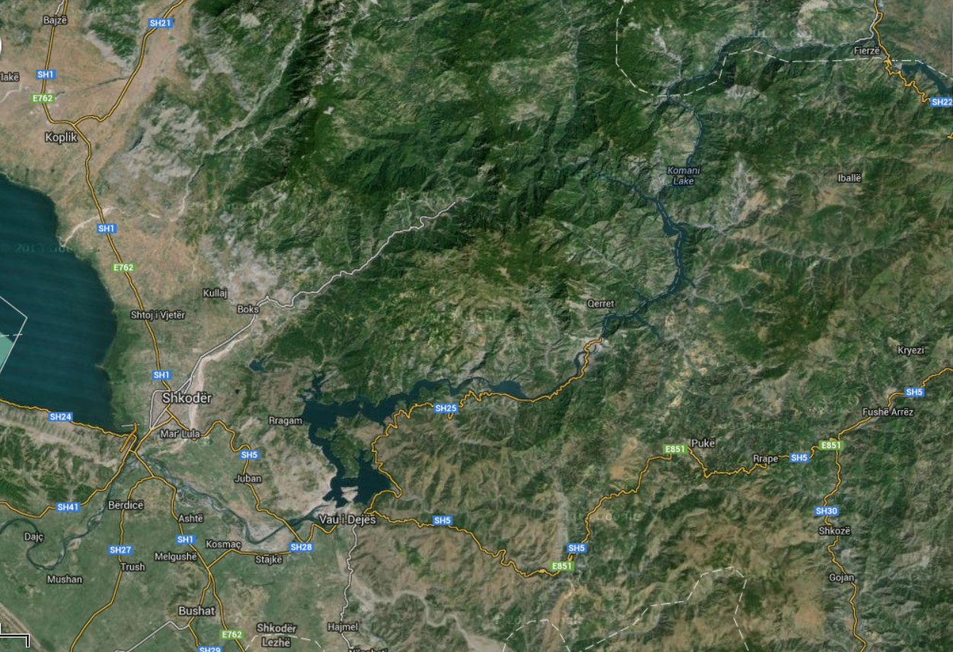

**Shkodra**

**Bushat (landfill)**

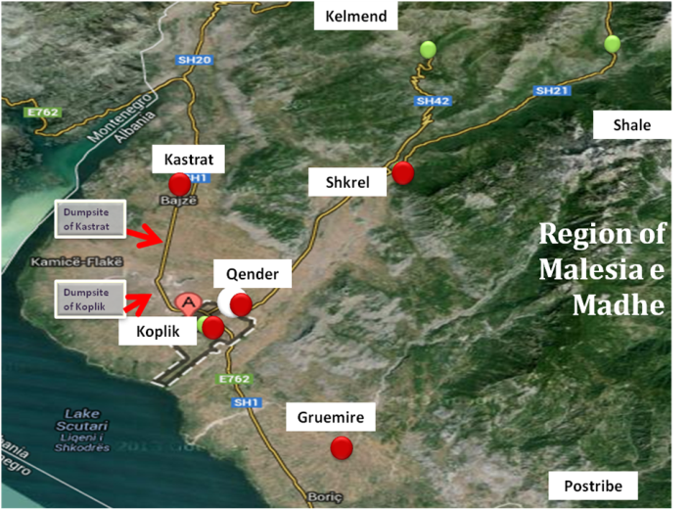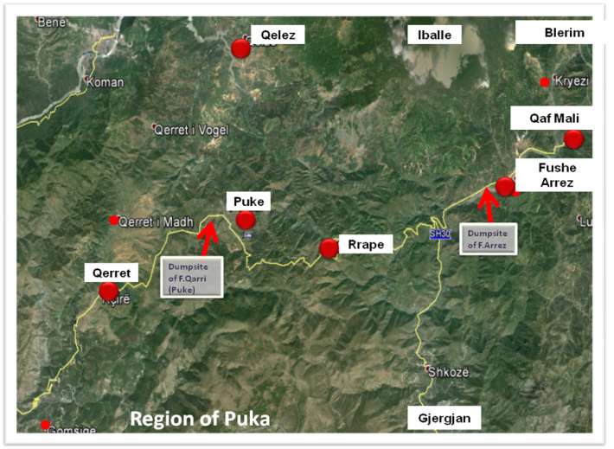

Figure 12 : localisation of the regions and LGUs (source: google map)

### Learnings in 2013

The expected cost reduction in both regions are presented in Figure 13. The base scenario, to which the cost of the interLGUs scheme is compared, considers that each LGU provides its own service (i.e. each LGU goes individually to the waste treatment plant and owns its own trucks and bins).

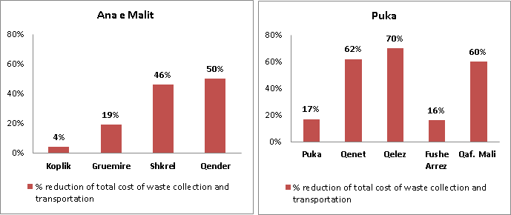

Figure 13 : Theoretical reduction of the waste management cost with an interLGUs scheme for selected LGUs

Regarding the region of Malesia e Madhe, the municipalities of Shkrel and Qender do not provide any service nowadays. Therefore, the initial investment in the base scenario linked to the acquisition of the appropriate number of trucks and bins represents a major cost. Optimizing the total number of trucks needed to provide a sufficient service and sharing the investment cost between municipalities of an interLGUs group allows LGUs to provide a proper service at reduced costs. For Koplik, the benefit of being part of an interLGUs group is lower as this municipality already provides an extended service, so no major investment expenses are expected in the base scenario. The situation is similar in Puka region, where in Qerret, Qelez and Qafe Mali, the service is not provided properly.

In addition to the cost reduction of the waste management system, the interLGUs collaboration allows an extension of the service at a reduced cost to areas initially unserved. For instance, Puka’s waste system initially served 33% of the region, while with the interLGUs scheme, the service can be extended to 54% (Figure 12).

|  |  |  |
| --- | --- | --- |
|  | **Current** | **InterLGU scheme (projection)** |
| **Puka** | 33% | 54% |
| **Malesia e Madhe** | 30% | 65% |

Figure 14 : Average regional coverage of the waste management system

The scheme proposed in Puka and Malesia e Madhe will be further consolidated, implemented and monitored, as all LGUs showed great interest to be part of it. The challenge remains at the institutional level, as these interLGU groups need to be built without any existing model on cost repartition, responsibilities, financing, monitoring, control,… among others[6].

### General recommendation on interLGU collaboration

The recommendations formulated to policy makers on LGU collaboration are the following ones:

1. Based on the significant cost reduction estimations and service extension, interLGUs schemes should be promoted as an efficient way to reduce the public services’ costs. On this regard, the foreseen territorial reform will impact the optimization of public services and should take in account the existing studies on interLGU groups.
2. To satisfy the lack of experience on the mechanisms and **institutional models** and therefore to facilitate the implementation of such an organization, tools should be provided by the national government to the LGUs willing to collaborate together on their waste management system.
3. The previous experiences also showed that the implementation is eased and the benefits are greater if a more advanced and **experimented LGU leads the interLGUs scheme**.

## Optimization of waste transport through transfer stations

### Presentation of the situation

Transportation costs represent an important part of the total cost of the service which includes the collection, transportation and disposal costs. Several studies have demonstrated the great potential of cost reduction through the implementation of transfer stations. Transfer stations are hubs at which local waste collection trucks temporarily deposit the collected waste before it is charged on larger trucks and routed to the waste treatment plant. There are currently no transfer station in the country but the concept has been introduced in the (draft) regional strategies.



Figure 15 : InterLGU groups and transfer stations as a mean to reduce the costs of the waste management system

### Support provided by dldp in 2013

In 2013, dldp studied the feasibility of the implementation of a transfer station in Shkodra. The main reasons justifying this study were the potential cost reductions, facilitation of the use of the regional landfill, reduction of the illegal dumping and the development of a pilot providing technical, financial and institutional models, tools and figures which could then be replicated in other regions.

### Learnings in 2013

The results of Shkodra’s feasibility study are presented below (Figure 14) and indicate no economic interest when Shkodra’s present conditions are considered.

The transfer station allows a reduction on transport costs of 1.16 €/ton of waste. But the operation of the transfer station has a cost, which has been estimated around 1.20 €/ton and therefore compensates the economy of transport. Moreover, the amortization cost of the transfer station must be considered, and the final figures show that implementing a transfer station in Shkodra would induce an increase of 1.27€/ton of the cost of the system.

|  |  |
| --- | --- |
| Transport without transfer station (with collection trucks, reference scenario) | 2.20 €/t |
| Transport with transfer station (90m3) | 1.15 €/t |
| **Economy on transport** | **- 1.16 €/t** |
| Operation cost of the transfer station | 1.20 €/t |
| Amortization cost of the transfer station | 1.23 €/t |
| **Additional cost for the operation of the transfer station** | **+ 2.43 €/t** |
| **Effect of the transfer station on the operation costs** | **+ 1.27 €/t** |

Figure 16 : Financial results of Shkodra's transfer station feasibility study

### General recommendation on transfer stations

The recommendations formulated to policy makers on LGU collaboration are the following ones:

1. As presented in Figure 15, the financial interest of a transfer station depends on both the waste production and the distance to the disposal site. The curve gives an indication. Before any decision is taken about the implementation of a transfer station, **prefeasibility studies including** **cost/benefit analyses** should be undertaken.
2. The need and location of transfer stations must be thought and studied at the **regional level**, as it is for the landfills. The methodology on cost is a tool that can help redefining the map for these infrastructures.
3. Transfer stations are more likely to induce cost reduction if several LGUs use a shared waste management system, including the transfer station, under an **interLGU** scheme[7]. Therefore, the implementation of a transfer station is a good opportunity to develop an institutional model for interLGU cooperation, which should be supported by the national government.

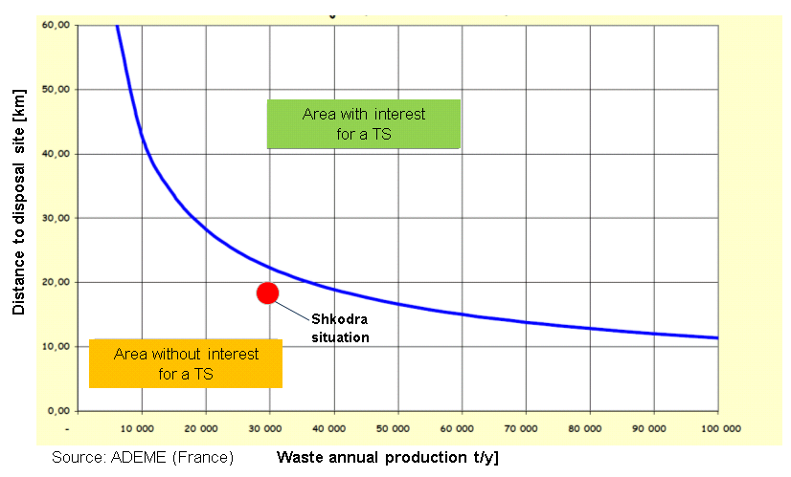

Figure 17 : Threshold between transfer stations inducing additional cost or reducing the cost of the system – Study conducted by ADEME (Agency of Environment and Energy Monitoring, France)

# Measurement campaigns

## Situation in LGUs

LGUs are mostly working with rough estimations on waste production data and these very theoretical figures are notably used to establish contracts with the providers of the cleaning services.

The amount of waste produced is an essential data for planning the needs for infrastructure and estimating the cost of the service.

## Support provided by dldp in 2013

In 2013, dldp launched measurement campaigns in Lezha, Shkodra and Shengjin with the aim of gathering accurate data for the future analyses, costs calculations and tariffs set up.

The results of the measurement campaigns and the comparison of the data gathered with the estimated data used as a base for contracts are presented in Figure 16. The estimated waste production used in Lezha corresponds relatively well to the results obtained from the measurement campaign, whereas in Shkodra and Shengjin especially, the estimated waste production is considerably greater than the one obtained through the measurement campaigns. The waste production per capita assumed in the national plan, and considered as a basis for planning and contracting purposes, are overestimated.

These differences show the need for measuring the quantities. At least, where no balance is available, quantities should be estimated based on trucks daily monitoring and counts.

|  |  |  |  |
| --- | --- | --- | --- |
|  | **Production per capita - comparison [kg/inh/d]** | | |
|  | **Base for contract** | **Measurements** | **National plan** |
| **Shkodra** | 1 | 0.7 | 1 |
| **Lezha** | 0.5 | 0.47 (weighted average)  0.72 (high season)  0.43 (low season) | 0.7 |
| **Shengjin** | 1.6 | 0.44 (weighted average)  0.58 (high season)  0.41 (low season) | 0.4 – 0.7 |

Figure 18 : Estimated and measured waste production in Shkodra, Lezha and Shengjin

In Lezha and Shengin, a survey on waste composition survey has been additionally conducted, which results are presented below. The proportion show the respective weight of each category of waste.

|  |  |  |
| --- | --- | --- |
|  | Lezha | Shengjin |
| August  2013 |  |  |
| November  2013 |  |  |

The results show that waste composition is not a constant and is influenced by seasonal, population, typology and economical resources parameters, among others. It can’t be set as a standard. This kind of survey are nevertheless useful to evaluate the potential on recycling materials, and must be carried out locally, case by case.

## General recommendations on measurements

The recommendations formulated to policy makers on measurements are the following ones:

1. As mentioned previously, monitoring is essential to pilot the service and to reflect the improvements in the cost analysis and in the tariffs. **Monitoring and reporting to the national level** is required for planning purposes. Policies should be introduced to oblige a follow up from the LGU, to measure, to register and to report, at least the **quantities of waste collected and disposed**. These measurements should become part of the day to day work. A important and necessary effort should be made to implement a working culture based on the use of real data.
2. Establishing the tenders and contracts of service providers based on tons of waste collected (and not in bins or trucks or other unit) should be stated as a good practice standard and implemented everywhere when a balance is available. The retribution of the service providers should be linked to the monitoring of the weight of waste collected.

# Tariff recovery and awareness campaigns

## Situation in LGUs

In many LGUs, the tariff recovery rate is very low and ranges between 5 to 75% depending on the LGU. Generally, the collection rate is high among the businesses, but low among the population. In this situation, the cost can’t be covered by the tariff’s collection. One option to increase the collection rate is to conduct an awareness campaign, with the objective to inform the population on the importance of paying for the service and to expose how this money is used for the collectivity.

To address the limited recovery rate issue, dldp organized awareness campaigns on tariff recovery in two rural LGUs (Velipoja and Ana e Malit) and in an urban one (Lehza).

## Learnings in 2013

Through workshops and roundtables with the population and the municipalities representatives, three main causes of nonpayment have been identified:

* **The service is badly or not delivered**

People do not accept paying for a service that they do not or irregularly receive. On the other hand, municipalities claim not having enough resources to extend the service. One option discussed with the population in Velipoja and Ana e Malit was to make them accept paying the tariff for a certain period, even though they would not receive the service, until the municipality could gather enough resources to extend the service. This proposition has not been accepted by the population, who was not confident enough in the capacity of the municipality to provide the service at short term.

* **Lack of transparency (on the calculation and on the use of the tariff)**

Transparency on tariff is lacking at two levels. First, the tariff is barely based on a cost analysis and calculation which makes is difficult to justify toward the population. The municipalities generally do not expose the way of calculating the tariff, nor the use they make of this money.

* Secondly, the tariff for cleaning services is usually collected together with other services, such as road maintenance and green areas maintenance. The bill doesn’t differentiate the tariff for cleaning service, that is hidden among other taxes, in a monthly “local tariff”. The people can’t understand which part is allocated to waste management.**Lack of collection tools (collection on population initiative only**)

The lack of means to collect the tariffs was pointed as a non-payment cause. Citizen do not receive a bill at home, they need to go personally to the municipal office to pay for the tariff, which is time consuming, and costly, for the more extended municipalities.

The amount of the bill has not been identified as a nonpayment cause.

***Actions conducted in Velipoja and Ana e Malit***

Awareness activities have been conducted in both LGUs, such as roundtables, TV spots, informative posters factsheets distribution or door to door education. The aim of the campaign was to promote inhabitants responsibility to pay the cleaning tax through cooperation mechanisms with local authorities. Obligation of the municipality regarding the cleaning service has been explained and related to the obligation of the citizens to pay for this service. The recovery rate has been increased in both LGUs, but remains low:

* Velipoja: 19% (2012) => 30% (2013)
* Ana e Malit: 17% (2012) => 33% (2013)

In these LGUs, the main message delivered by the population was that they would agree to pay for the service, but first, the service has to be delivered. This relationship has been illustrated in Puka where, thanks to the improvement of the service, the collection rate increased significantly:

* Puka : 5% (2011) => 69% (2013)

***Actions conducted in Lezha***

Broad awareness campaign has been conducted in Lezha toward the population, following the same objective. The message focused on the necessity to pay for the tariff to ensure the sustainability of the service. Cost structure has been communicated to explain how the citizen’s money is used to clean the city. The cost of this service has been related to the tariff and to daily expenses such as a cup of coffee.

In parallel, the city of Lehza linked administrative services to the payment of the tariff: to receive any official document from the municipality, one must show the proof that the tariff for cleaning service has been paid.

In Lezha, the recovery rate among families increased, but remains low, although the service is provided:

* Lezha: 5% (2011) => 16.5% (2012) => 37% (2013)

## General recommendation on tariff recovery and awareness campaigns

The recommendations formulated to policy makers on tariff recovery and awareness campaigns are the following ones:

1. To significantly increase the recovery rate, awareness campaign should accompany effective changes. The response of the population regarding the tariff payment varies a lot and depends of many factors such as the confidence toward the local government, the economical level, the size of the LGU and the “social pressure” coming from the neighbors, the awareness,… among others. Indeed, the tools can’t be generalized as the efficient ones and useless ones. From the experience capitalized, the following statements can be established:
   1. The service must be regularly and correctly provided to oblige the tariff payment.
   2. The cost and tariff calculation should be transparently communicated.
   3. The population should be educated toward its responsibility, through awareness campaigns.
   4. The collection of the fees should be regularly and proactively organized by the municipality, who should insist towards the bad payers (sending and resending the bill, frequently knocking at the door,…).
   5. Penalties should be enforced toward bad payers.
2. To be efficient, awareness and information campaigns should involve both the municipality and the community. They should be held on a long term basis, integrated in the municipal strategy as a key point for the success of the waste management system.

The option of financing waste management services through a special fund, fed with importation taxes, should be considered, as most waste are made of imported goods.

# Conclusion - overview of the recommendations

|  |
| --- |
| **Cost and tariff methodologies** |
| 1. A regulatory entity should be promoted as leader to adapt the proposed methodology and the legal framework in order to implement a national standard on cost and tariff calculation. 2. A broad training of the municipalities’ staff on cost and tariffs methodologies should be undertaken. 3. Rules and policies should be edited to force the LGUs monitor and report to the regional/national government their waste production and related costs of the waste management system. 4. The national government should set that the only official data to be used are the ones provided by the register offices. 5. The law on small businesses, which limits the fees paid by small businesses , should be revised. |
| **Recycling** |
| 1. A detailed and case-by-case cost/benefit analysis must be undertaken before deciding to implement a recycling scenario. 2. The top priority is to implement a sustainable basic service for waste collection and disposal. Then, the service can be extended and include sorting and recycling activities. 3. A legal framework for recycling activities should be set. 4. At source sorting is recommended. 5. To reduce the cost of implementing recycling activities, part of the responsibilities can be delegated to a private company under a public/private partnership. 6. Provide on incentives to reduce the proportion of organic material in the waste |
| **Optimization of waste collection and transport through interLGU schemes** |
| 1. InterLGUs schemes should be promoted as an efficient way to reduce the public services’ costs. 2. Tools and models facilitating the implementation of interLGUs waste management schemes should be provided by the national government to LGUs willing to collaborate together. 3. A more advanced and experimented LGU should lead the interLGUs scheme to ease the implementation and increase the benefits of interLGUs collaboration. |
| **Optimization of waste transport through transfer station** |
| 1. Pre-feasibility studies including cost/benefit analysis should be undertaken before any decision about the implementation of a transfer station is taken. 2. The need for a transfer station and its location should be studied at a regional level 3. To fully benefit from the potential cost reduction associated with the implementation of a transfer stations, the LGUs should be organized as an interLGUs scheme. |
| **Measurement campaigns** |
| 1. Policies should be set to oblige the LGUs monitor and report the quantity of waste collected and disposed. 2. A working culture based on the use of real data should be strongly promoted. |
| **Awareness campaign** |
| 1. Awareness campaigns should involve both the municipality and the community and be conducted simultaneously with observable changes. 2. Awareness and information campaign should be held on a long term basis and integrated in the municipal strategy as a key point for the success of the waste management system. |

**Table of references**

* Calculating the cost for solid waste management at local government unit level in Alabania, dldp, 2013.
* Summary of project proposal : Establishment of Public Private Partnership to enable separate waste stream collection in Shkodra Municipality, Konalsi Gjoka, 2013.
* Support Inter-LGU Cooperation and organization of waste management service in Lezha and Shengjin, URI (Urban Research Institute), 2013.
* Paper on inter-municipal collaboration on waste sector-based on the cases studied in region of Puka and Malesia e Madhe, Co-PLAN and HELVETAS Swiss inter-cooperation, 2013.
* Tariffs for waste – Manual for different models, REC, 2013
* I do my part in keeping my village clean, Environmental Center for Development Education and Networking, 2013.
* Interviews of the service providers and representatives of the beneficiary LGUs, conducted in December 2013.
* Implementation of the National Plan for Approximation of Environmental Legislation in Albania, EU, 2010

1. The transfer of such data’s from national to local level it’s a MUST for feasibility analyses
2. The statement reflects the context of the previous year
3. This waste amount represents the annual daily weighted average that has come out from the measurement campaign
4. Zone A in Lezha is the only service area that is covered up to 90% with the two – stream – differentiated collection system
5. It should be stated that interLGU schemes in case of territorial reform (see the dldp study on Functional Areas) might be substituted with bigger LGU-s.
6. The territorial reform might shift this focus of challenge
7. InterLGU scheme remains relevant even on bigger LGU-s coming out of the potential territorial reform, because in this context it represents an economy of scale unit